
ORIENTAL COLLEGE OF TECHNOLOGY, BHOPAL
Department of Computer Science and Engineering
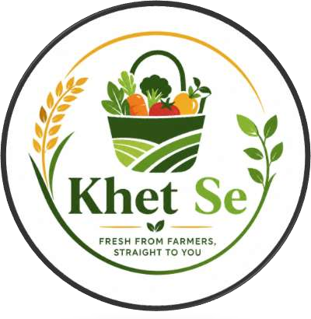

PROJECT REPORT
KHET SE
Direct Farmer-to-Consumer Digital Marketplace Platform
"Fresh from Farmers, Straight to You"
Theme: Agriculture, FoodTech & Rural Innovation | Category: Software
Submitted for: BGI Viksit Bharat National Hackathon
Team Name: Kishan Crew
Himanshu Lal Das • Avnika Jain • Chetna Bisen
Dakshita Mishra • Ashish Kumar
Live Prototype: https://himanshu791-code.github.io/Khet-Se/

1. Team Details
S.No. | Team Member | Branch / Institution
1 | Himanshu Lal Das | B.Tech CSE, Oriental College of Technology, Bhopal
2 | Avnika Jain | B.Tech CSE, Oriental College of Technology, Bhopal
3 | Chetna Bisen | B.Tech CSE, Oriental College of Technology, Bhopal
4 | Dakshita Mishra | B.Tech CSE, Oriental College of Technology, Bhopal
5 | Ashish Kumar | B.Tech CSE, Oriental College of Technology, Bhopal

Team Name: Kishan Crew | Project Title: Khet Se | Event: BGI Viksit Bharat National Hackathon

2. Abstract
Khet Se is a user-friendly, AI-enabled digital marketplace that connects farmers directly with consumers, removing intermediaries from the agricultural supply chain. The platform provides transparent price comparison between mandi and farmer prices, farm-to-home delivery with order tracking, and dedicated interfaces for farmers, consumers, administrators and delivery partners. To make the platform accessible to users with limited digital literacy, Khet Se offers multilingual support (including Hindi), voice commands, an AI-based search box and an AI chatbot. The project aims to increase farmer income, give consumers fresher and fairer-priced produce, and encourage rural digitization in line with the Digital India vision.

3. Introduction and Problem Statement
Indian farmers depend heavily on traditional mandis and layers of middlemen, which reduces their share of the final consumer price and delays payments. Consumers, on the other hand, pay higher retail prices and have little visibility into the origin, freshness and fair price of the produce they buy. Existing platforms tend to address only isolated parts of this problem.

Key problems identified
- Farmers lose a large share of their profit to middlemen and have limited control over pricing.
- Payments to farmers are often slow and unreliable.
- Consumers lack transparency about source, quality and fair pricing of produce.
- Low digital literacy and poor connectivity in rural areas act as barriers to adoption.
- Perishable goods need efficient last-mile delivery and demand-supply planning.

4. Proposed Solution
Khet Se integrates a marketplace, price transparency, AI guidance and a simple user interface into one unified system. Farmers list produce and manage inventory directly; consumers browse, search and order fresh, local produce; administrators monitor the platform through a dashboard; and delivery partners handle order fulfilment with live tracking.

Multi-role integrated platform
Role | Capabilities
Farmer | List products, manage inventory, control pricing, receive orders and payments
Consumer | Browse, search, compare prices, order, track delivery, pay online or by COD
Admin | Dashboard and analytics for monitoring users, orders and platform performance
Delivery Partner | Order tracking system and local delivery management

Unique Value Proposition
- Authentication for every user (farmer and consumer), completed in less than a minute.
- Multilingual support, including a Hindi toggle.
- AI-based search box and chatbot for guidance.
- Voice command support for low-literacy users.
- Fair price comparison (mandi vs farmer price) that builds customer trust.
- Focus on fresh and local produce, and support for organic farming.
- Live map of nearby farmers and delivery, with delivery partner details and OTP-based handover.
- Analytics dashboard showing orders, revenue and the amount saved from middlemen.

5. System Design and Technology Stack

5.1 Current prototype implementation
The live prototype at https://himanshu791-code.github.io/Khet-Se/ is a front-end web demonstration built entirely with HTML5, CSS3 and JavaScript, and hosted as a static site on GitHub Pages. It reproduces the full user flow described in Section 6 (login, home, farmer listing, market, orders and tracking, live map and the analytics dashboard) using sample/mock data, so that judges and users can experience the intended product without a live backend.
Component | Technology used in the current prototype
Structure and styling | HTML5, CSS3
Interactivity and app logic | JavaScript (client-side, no backend calls)
Data used in the demo | Sample/mock data (products, orders, prices, dashboard stats)
Hosting | GitHub Pages (static hosting), source on GitHub

5.2 Planned production technology stack
For the full product, the team has designed the following technology stack, as outlined in the solution approach:
Component | Planned Technology / Approach
Backend / core platform | Node.js and Express.js
Mobile application | Flutter (cross-platform compatibility)
Database | MongoDB (document-oriented NoSQL database)
APIs | REST APIs
Authentication | Firebase Auth / JWT
Cloud | Firebase / AWS
Payments | Razorpay (UPI, online payments, COD option)
Notifications | Firebase Cloud Messaging
Maps and location | Google Maps APIs
Security | Custom encryption algorithm (8-layer, octa 512-bit) for secure data transmission and authentication

5.3 Process flow
A user opens the website and selects a role (Farmer or Consumer) and logs in. Farmers list their produce through the Farmer Portal. Consumers browse fresh produce from local farms, compare prices, add items to the cart, place the order and track it until delivery, using the live map if needed. Administrators monitor the platform through the analytics dashboard. Section 6 explains each screen in detail.
Login → Home → Farmer Listing → Market → Cart → Order Tracking → Live Map → Dashboard

6. Prototype and Website Workflow
A working prototype of Khet Se is hosted online at https://himanshu791-code.github.io/Khet-Se/. The screens below follow the actual workflow of the website, from login to the admin analytics dashboard, with an explanation of what each screen does. Prices, orders and statistics shown in the screenshots are sample data used for demonstration.

Step 1: Login and Role Selection
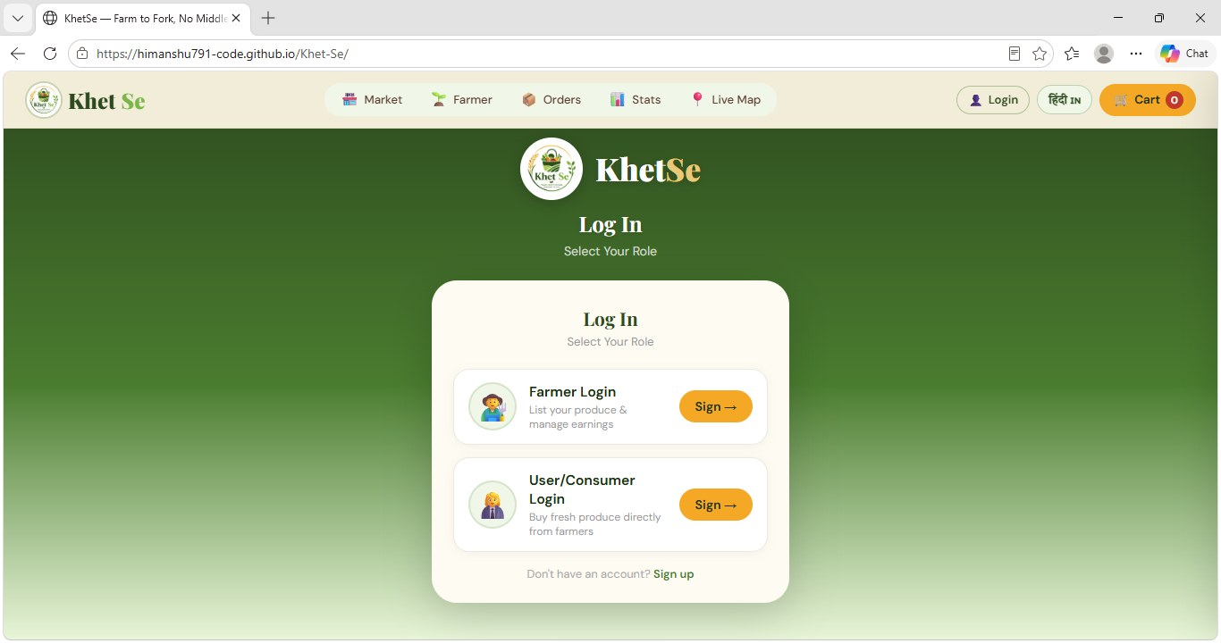
Figure 1: Login and role selection screen
The user starts on the login screen and selects a role. The header, which stays on every page, gives quick access to Market, Farmer, Orders, Stats and Live Map, along with the language toggle (Hindi) and the cart.
- Role-based login: Farmer Login (list produce and manage earnings) and User/Consumer Login (buy fresh produce directly from farmers).
- Sign up: New users can create an account from the same screen.
- Accessibility: A Hindi language toggle is available in the top bar for rural and Hindi-speaking users.

Step 2: Home Page
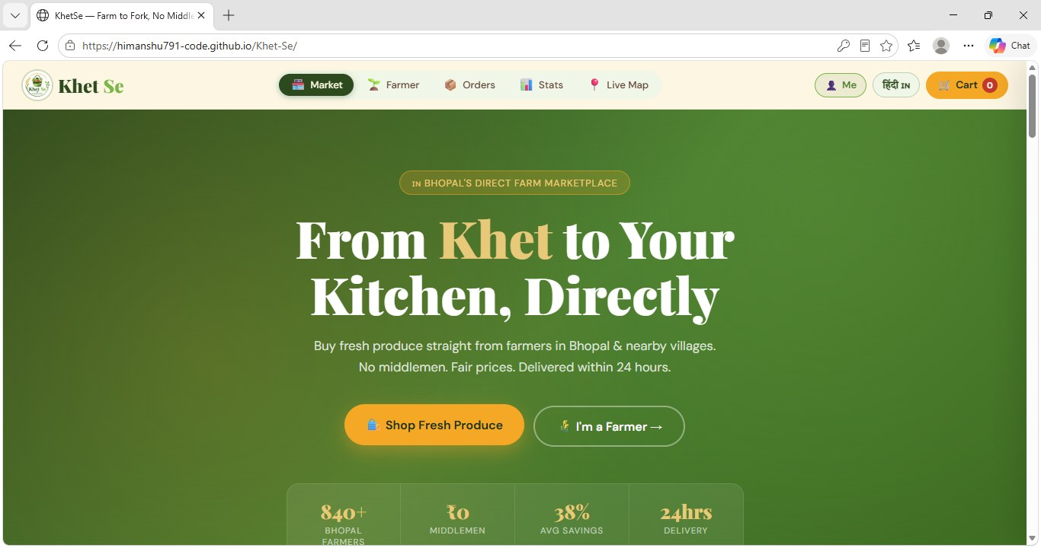
Figure 2: Home page
After login, the user lands on the home page, which communicates the core idea of the platform: fresh produce straight from farmers in Bhopal and nearby villages, with no middlemen, fair prices and delivery within 24 hours.
- Call to action: "Shop Fresh Produce" takes consumers to the market; "I'm a Farmer" takes farmers to their portal.
- Highlights: Key figures shown on the page include 840+ Bhopal farmers, Rs. 0 middlemen, 38% average savings and 24-hour delivery.

Step 3: Farmer Portal (Listing Produce)
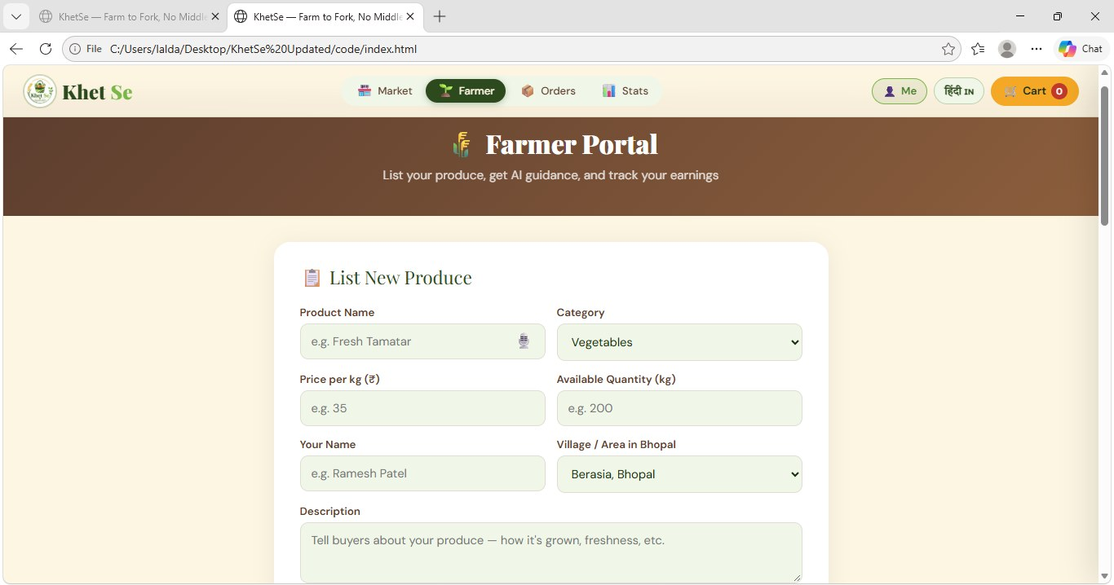
Figure 3: Farmer portal - list new produce
On the supply side, a farmer uses the Farmer Portal to list produce so that it appears in the marketplace. The form is kept short and simple for easy use.
- Form fields: Product name, category, price per kg, available quantity, farmer name, village/area in Bhopal, and a description of how the produce is grown.
- Voice input: A microphone icon in the product name field lets farmers speak instead of typing.
- Farmer control: The farmer sets the price directly, with AI guidance and earnings tracking mentioned in the portal.

Step 4: Market - Browsing Fresh Produce
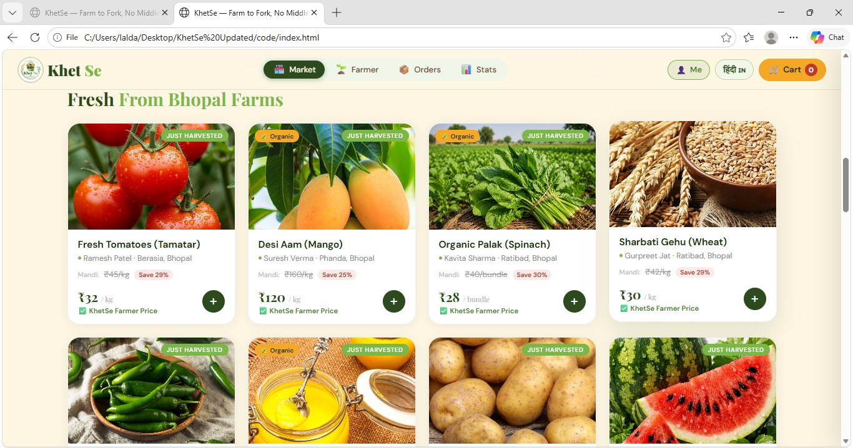
Figure 4: Market - Fresh From Bhopal Farms
Consumers browse the market ("Fresh From Bhopal Farms"), where each product is shown as a card with the farmer's name and area. Tapping the + button adds the product to the cart, which is shown at the top right.
- Price transparency: Each card shows the mandi price (struck through), the percentage saved, and the KhetSe Farmer Price.
- Trust and quality tags: "Just Harvested" and "Organic" tags, plus the farmer's name and location, show the source of the produce.
- Local focus: Products are listed from farmers of nearby areas such as Berasia, Phanda and Ratibad.

Step 5: Orders and Order Tracking
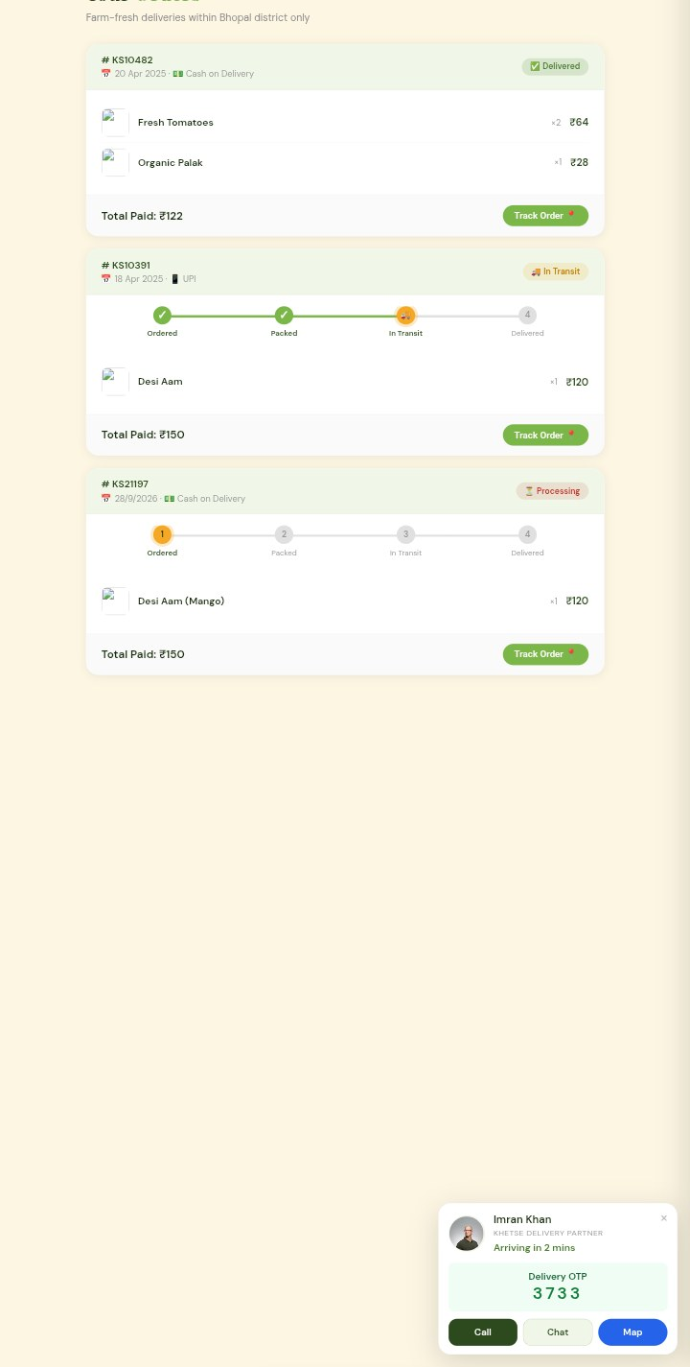  Figure 5: Orders and tracking (mobile view) | After checkout, the Orders page lists the consumer's orders with their payment mode and status. The website works on mobile phones, as shown here.  - Order status: Each order shows a status such as Delivered, In Transit or Processing.  - Tracking steps: A four-stage tracker shows Ordered, Packed, In Transit and Delivered.  - Payment options: Orders are marked as Cash on Delivery or UPI.  - Delivery partner card: Shows the delivery partner's name, estimated arrival time, a delivery OTP for safe handover, and Call, Chat and Map buttons.

Step 6: Live Map - Nearby Farmers and Live Delivery
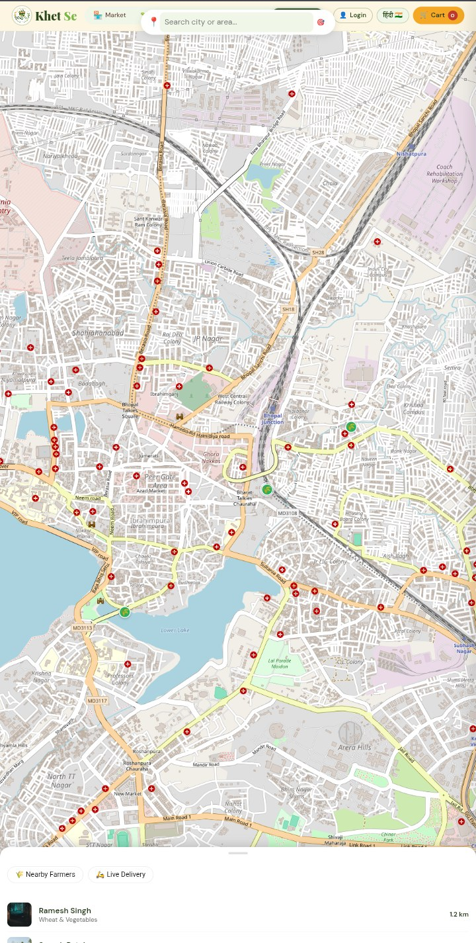  Figure 6: Live map (mobile view) | The Live Map helps consumers find farmers around them and follow deliveries on a map of Bhopal.  - Location search: A search bar lets the user search a city or area.  - Nearby Farmers: A panel at the bottom lists nearby farmers with the type of produce and the distance (for example, 1.2 km).  - Live Delivery: A second tab is provided to follow delivery in progress.

Step 7: Platform Dashboard (Stats)
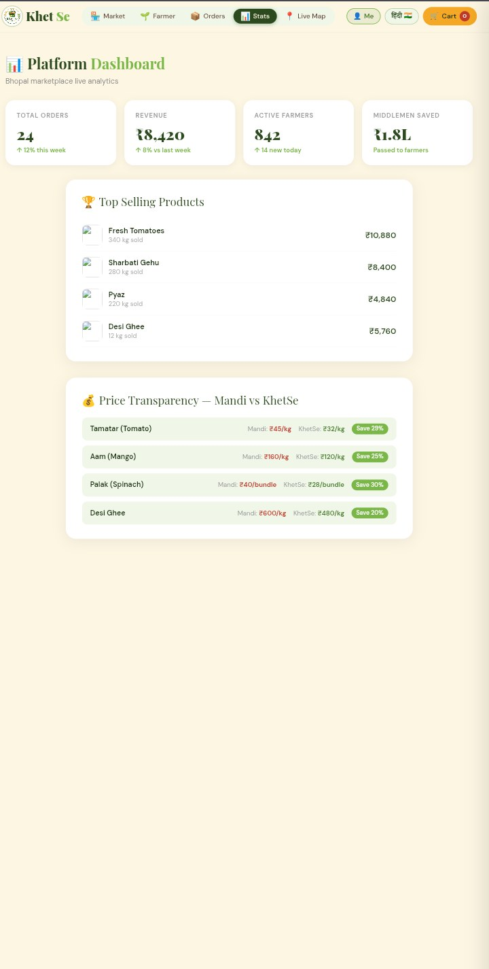  Figure 7: Platform dashboard (mobile view) | The Stats page works as an analytics dashboard for the platform and shows the impact of removing middlemen. The figures shown are sample data.  - Summary cards: Total orders, revenue, active farmers and the amount saved from middlemen (passed on to farmers).  - Top Selling Products: Best-selling items with quantity sold and revenue.  - Price Transparency: A table comparing mandi price with KhetSe price and the percentage saved for products such as tomato, mango, spinach and desi ghee.

Overall flow: Login and role selection → Home page → Farmer lists produce → Consumer browses market and adds to cart → Order placed and tracked → Live map and delivery → Analytics dashboard.

7. Feasibility and Viability

7.1 Technical feasibility
The team assessed technical feasibility at 85%, based on the use of mature, widely supported technologies (Node.js, Express, MongoDB, Flutter, Firebase, Razorpay and Google Maps APIs).

7.2 Operational feasibility
- Simple UI with icons, Hindi toggle and voice input.
- Farmer-friendly listing form for easy product upload.
- Local delivery model based on hyperlocal clusters.

7.3 Challenges and proposed solutions
No. | Challenge | Description | Proposed Solution
1 | Farmer adoption | Low trust in digital platforms and limited technical skills | Awareness campaigns, FPO partnerships, Hindi and voice support, field agents
2 | Logistics and delivery | Last-mile delivery of perishables | Hyperlocal model, delivery partners, route optimization, cluster deliveries
3 | Quality assurance and trust | Doubts about freshness and authenticity | Farmer verification, ratings and reviews, product details, quality checks
4 | Price fluctuation | Daily price changes and mandi competition | Dynamic pricing, mandi vs farmer price comparison, AI price prediction
5 | Payment challenges | Preference for cash; failed transactions; delayed settlements | COD and UPI options, secure payments, fast and assured settlements
6 | Technology barriers | Low digital literacy, poor connectivity | Simple UI, voice input, Hindi support, offline mode, low data usage
7 | Supply-demand imbalance | Overproduction causes wastage; shortages cause dissatisfaction | AI demand prediction, pre-orders, real-time alerts to farmers
8 | Competition | BigBasket, DeHaat, local vendors | AI assistant, transparency, local model, fair pricing
9 | Legal and regulatory | GST, FSSAI, e-commerce and data regulations | Proper registration, guidelines, automated invoicing and compliance
10 | Farmer retention | Low sales, delayed payments, less support | Analytics dashboard, incentives, training, fast payments and support
11 | Customer retention | Switch to local vendors or cheaper platforms | Loyalty programs, subscriptions, personalized offers, excellent UX
12 | Scaling | Expansion adds logistics and operational complexity | City-wise expansion, local partnerships, strong backend and modular system

7.4 Competitive comparison (team self-assessment)
Feature | Existing Apps | Khet Se Prototype | Advantage Score
Direct farmer to consumer | Partial | Full | 95%
Price transparency (mandi vs farmer) | Rare | Strong feature | 90%
AI farmer assistant | Very limited | Included | 92%
Voice and Hindi support | Partial | Strong | 88%
Full UI flow (cart, orders, tracking) | Partial | Complete | 96%
Local marketplace model | Some | Clearly implemented | 90%
Overall advantage score: approximately 92% (6 out of 6 features superior, as assessed by the team).

7.5 Revenue model
- Commission of 2–5% per order.
- Subscription for farmers (premium listing).
- Delivery charges.
- Advertisements (agri products, fertilizers).

8. Impact and Benefits
Stakeholder | Impact
Farmers (primary target) | Higher profit margins without middlemen; direct control over pricing; faster and more reliable payments; access to a larger digital market beyond local mandis; better demand visibility; shift from traditional to digital selling, with greater confidence and independence
Consumers (urban and semi-urban) | Lower prices compared to retail/mandi; fresher, farm-direct produce; transparency of source and pricing; easy ordering, tracking and delivery; digital payment and COD
Local vendors and retailers | Direct sourcing from farmers, reduced procurement cost, stable supply chain, better price negotiation
Delivery partners and local workforce | Job creation as delivery agents and logistics coordinators, with work opportunities within the local region
Government and policy makers | Strengthens the agriculture economy and farmer income; supports Digital India and AgriTech initiatives; encourages rural digitization; reduces dependency on the traditional mandi system

9. Current Status and Future Scope
As per the project presentation, approximately 70% of the product has been built. Further development is in progress, and testing and validation are the next stages.

Future scope
- Complete testing and validation with real farmers and consumers.
- Launch the Flutter mobile application.
- Expand AI features such as price prediction and demand forecasting.
- Add offline mode and further regional language support.
- Expand city by city through local partnerships and FPOs.

10. Hackathon Participation
Team Kishan Crew (Team ID 676) presented Khet Se at the BGI Hackathon 2026 - Vision 2047 | Viksit Bharat, a national-level innovation platform organized by Bansal Group of Institutes at the BGI-Kokta Campus, Bhopal on 13-14 May 2026, under the theme Agriculture, FoodTech & Rural Innovation.
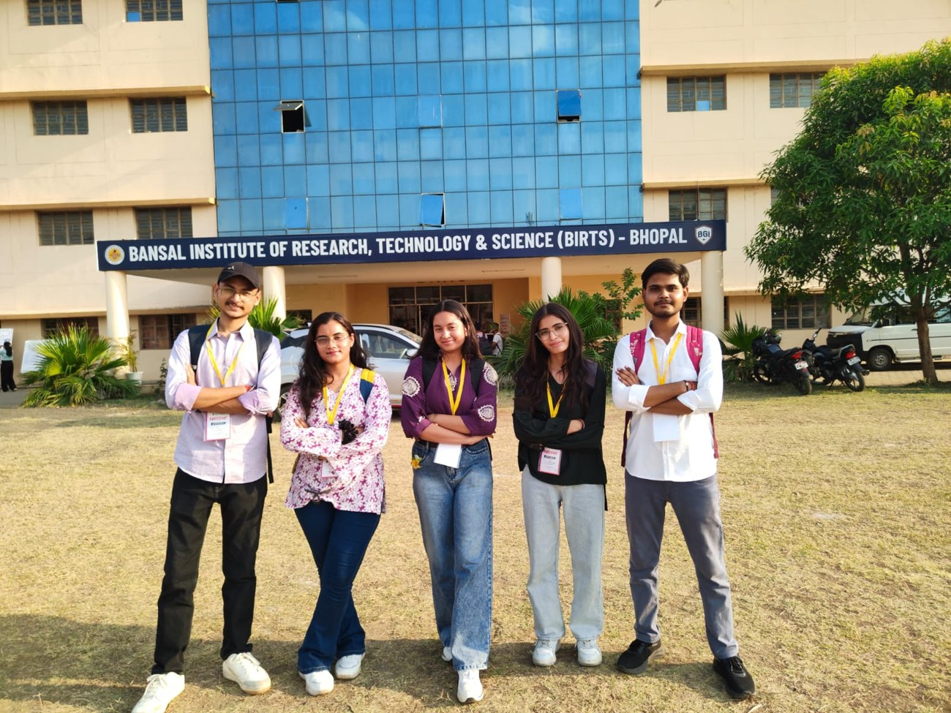
Figure 8: The team arriving at Bansal Institute of Research, Technology & Science (BIRTS), Bhopal, the hackathon venue
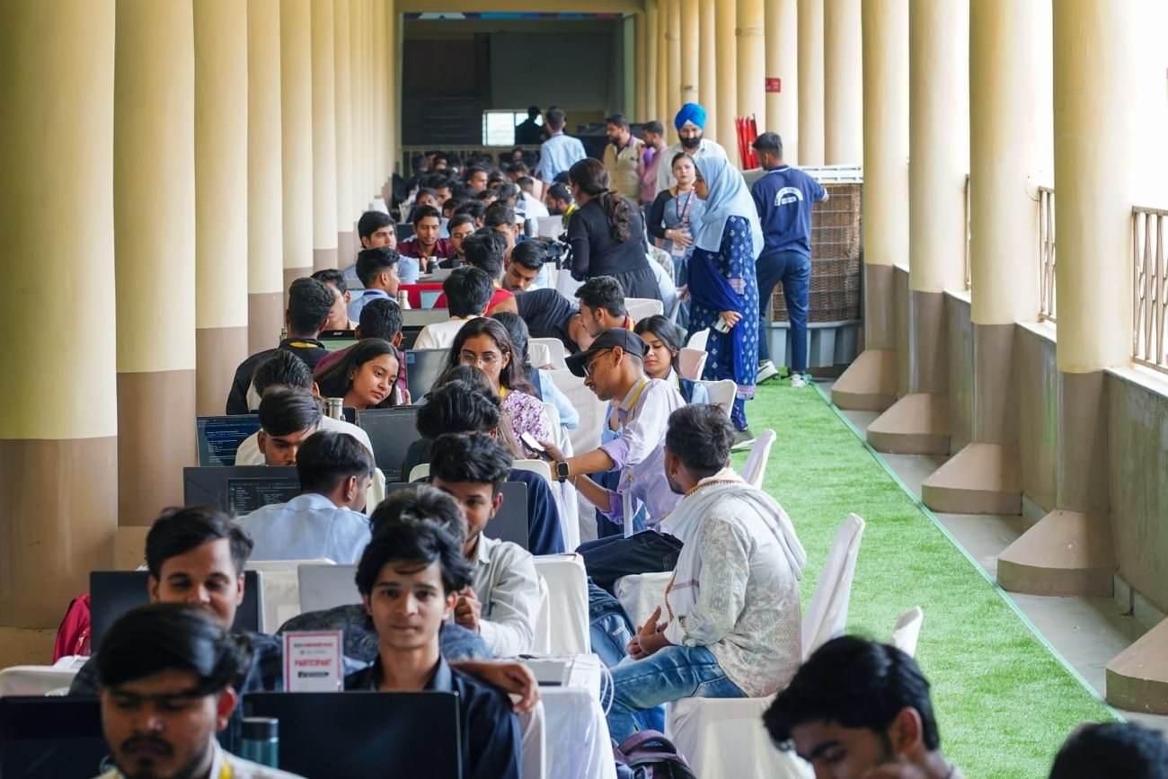
Figure 9: Participating teams at work during the hackathon
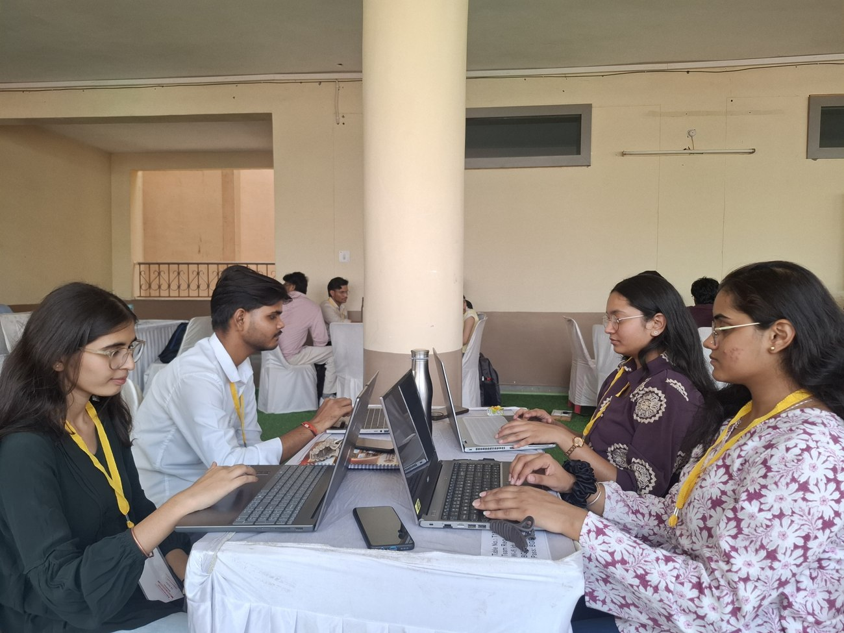
Figure 10: Team members collaborating on the Khet Se prototype
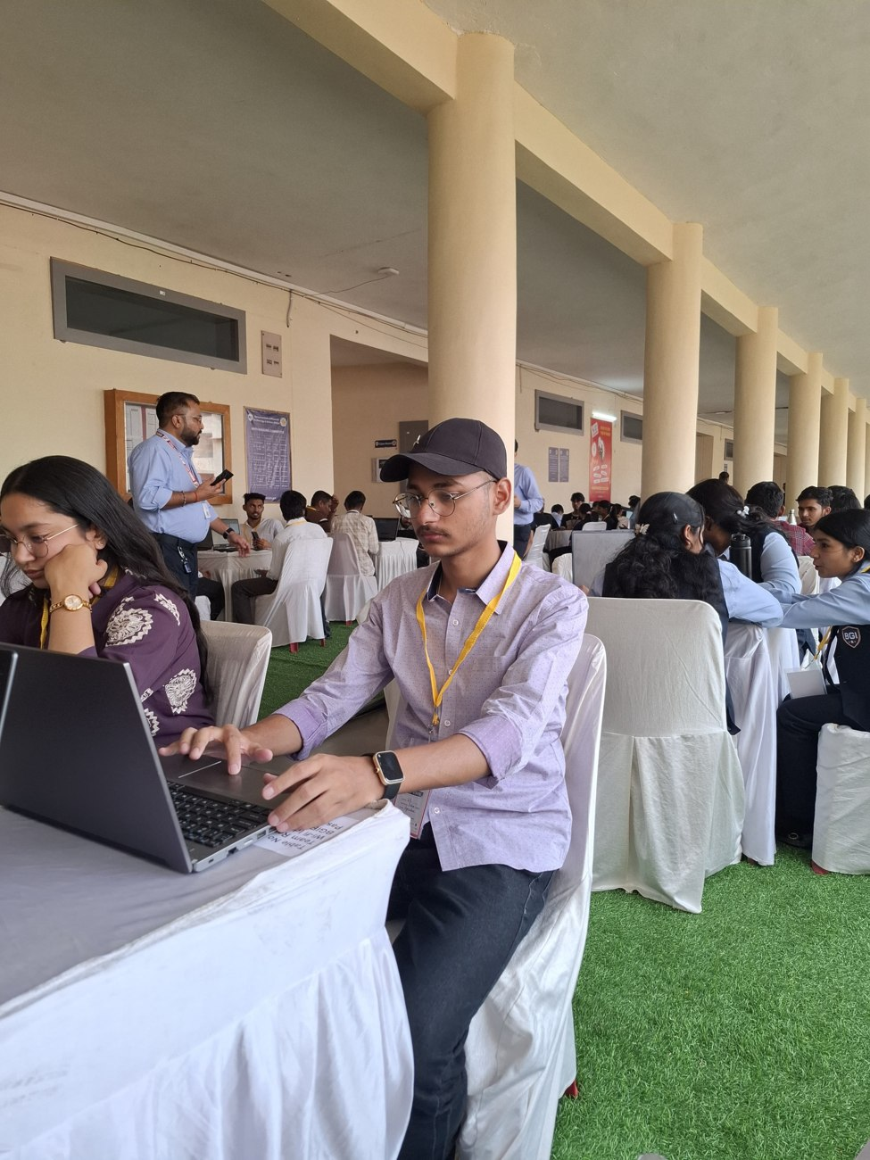
Figure 11: A team member working on the code during development
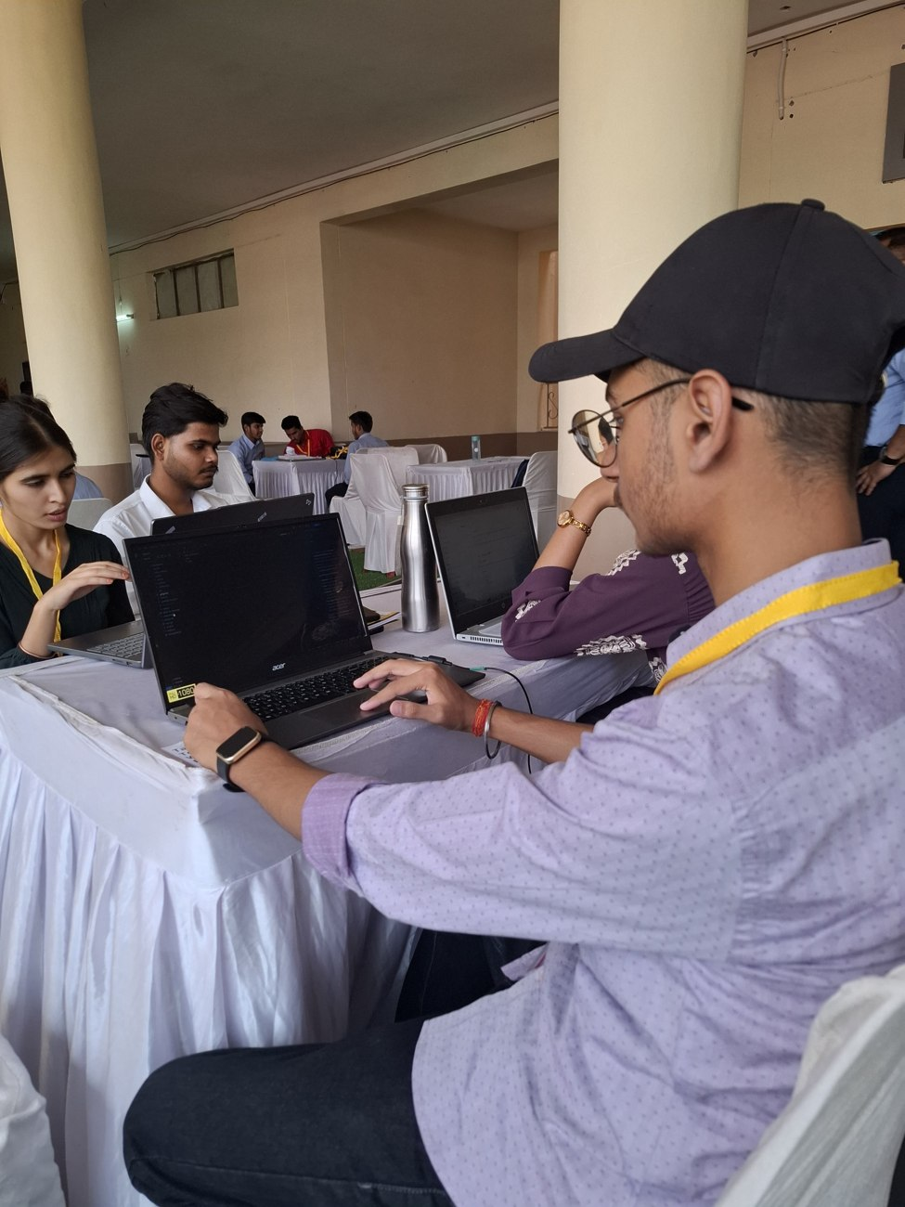
Figure 12: The team continuing development work during the hackathon
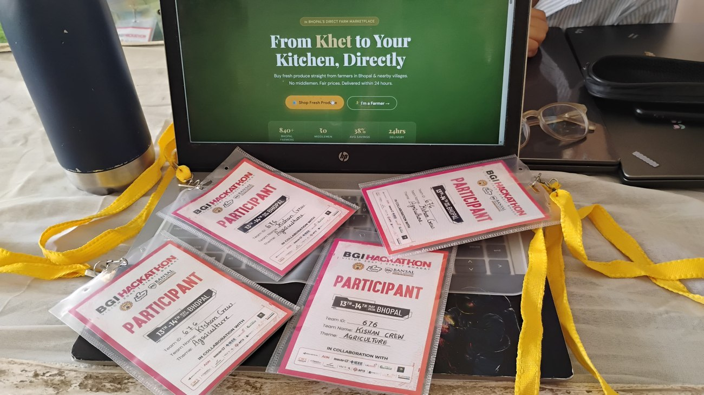
Figure 13: The Khet Se home page running on the laptop, alongside the team's hackathon participant passes
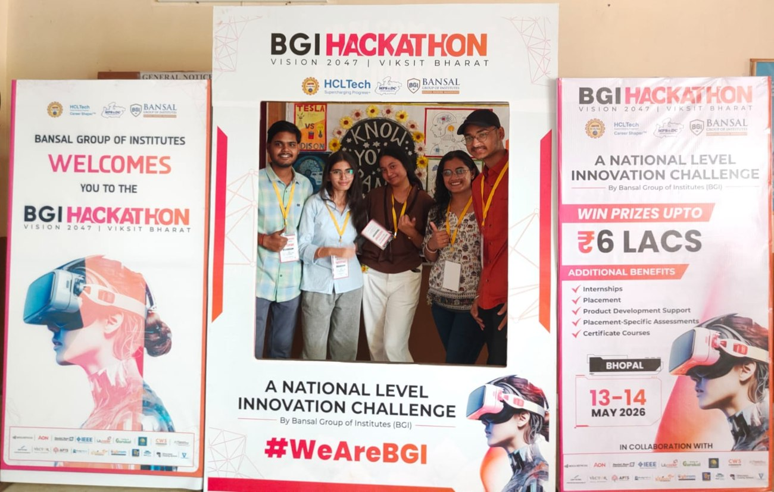
Figure 14: Team photo at the BGI Hackathon photo booth
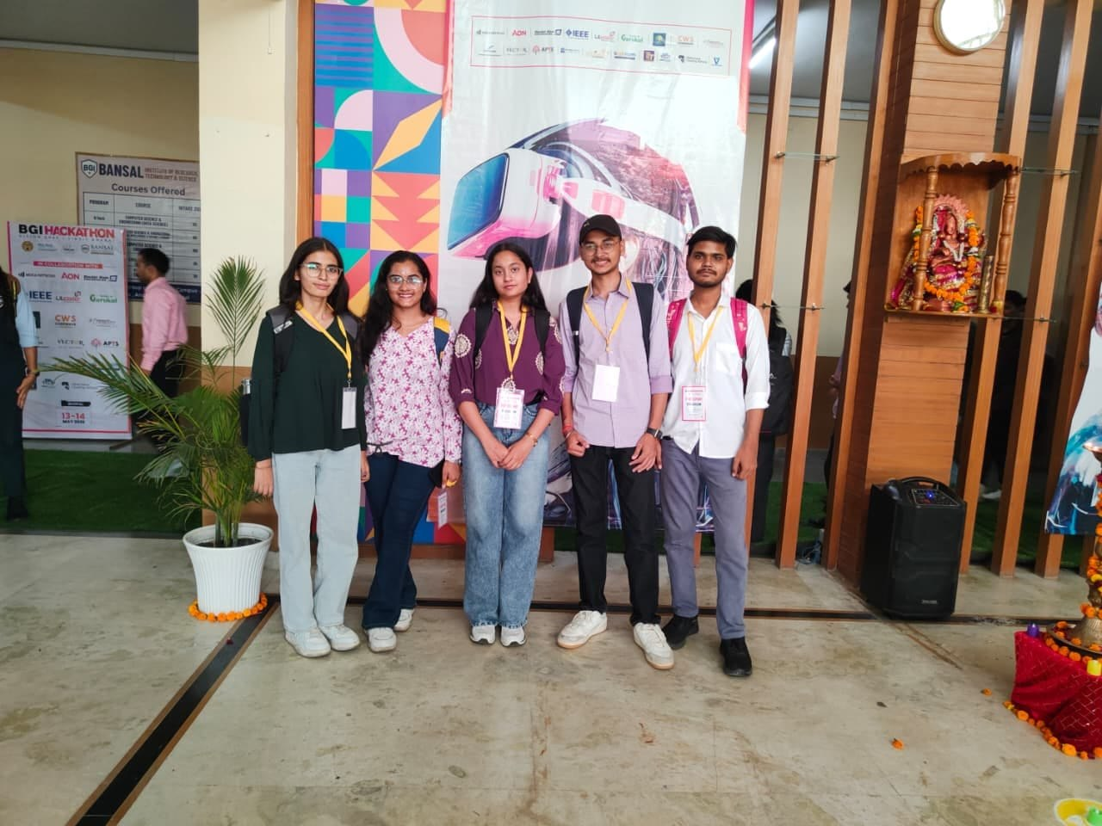
Figure 15: Team group photo at the hackathon venue

Certificates
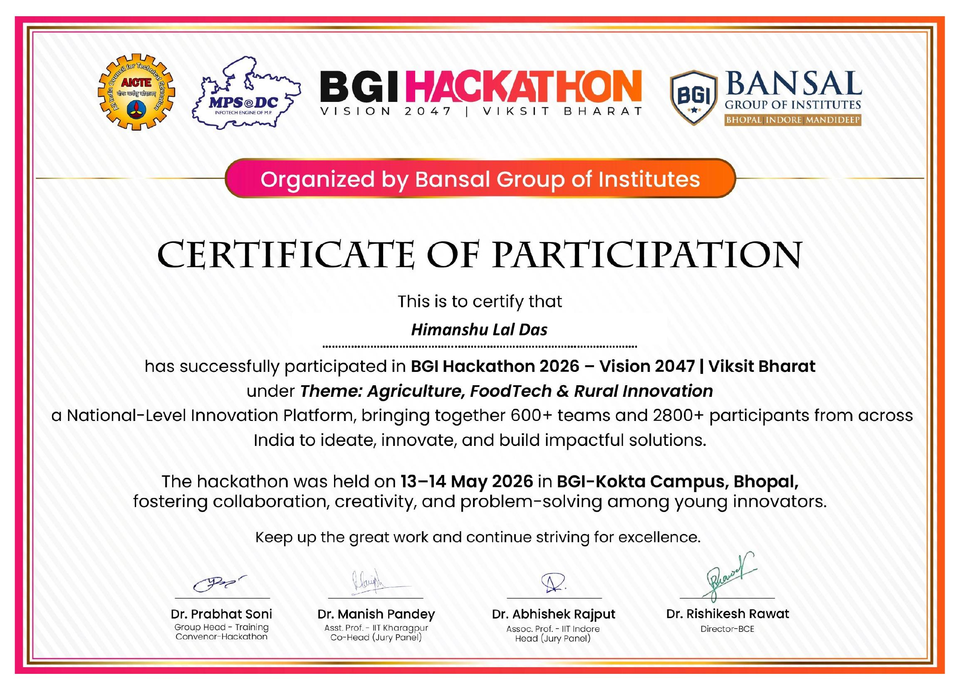
Figure 16: Certificate of Participation issued to Himanshu Lal Das for BGI Hackathon 2026
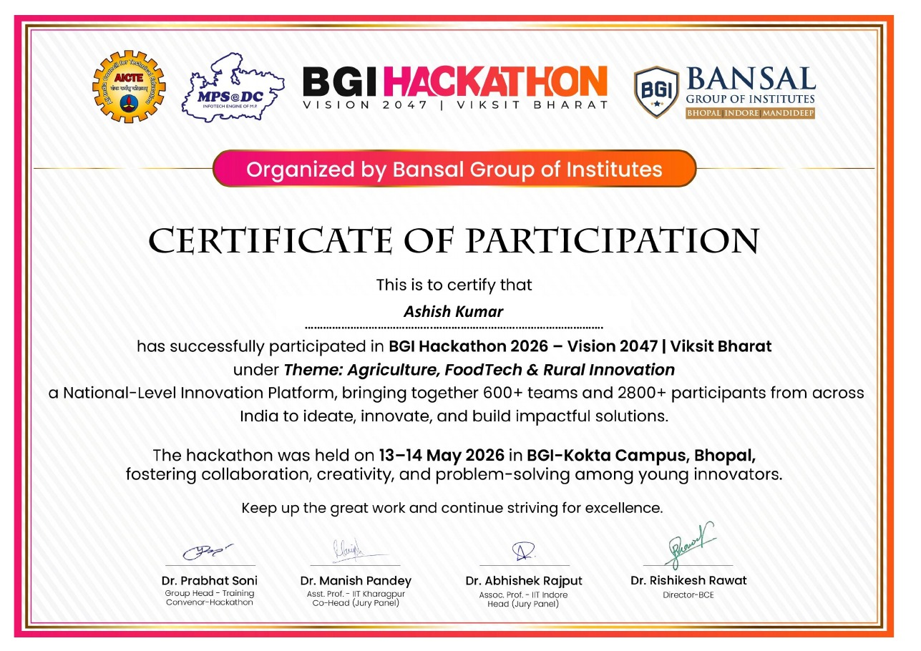
Figure 17: Certificate of Participation issued to Ashish Kumar for BGI Hackathon 2026
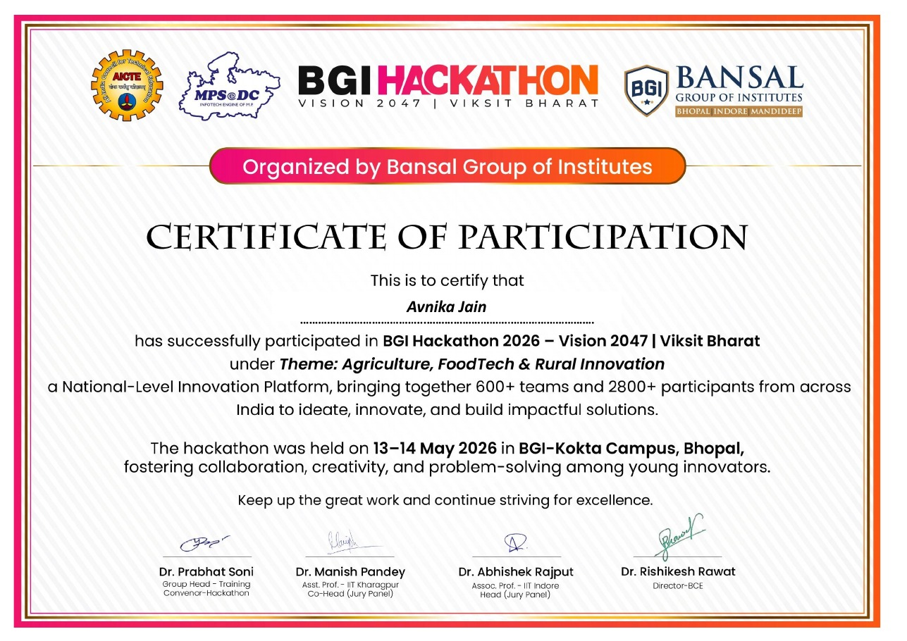
Figure 18: Certificate of Participation issued to Avnika Jain for BGI Hackathon 2026
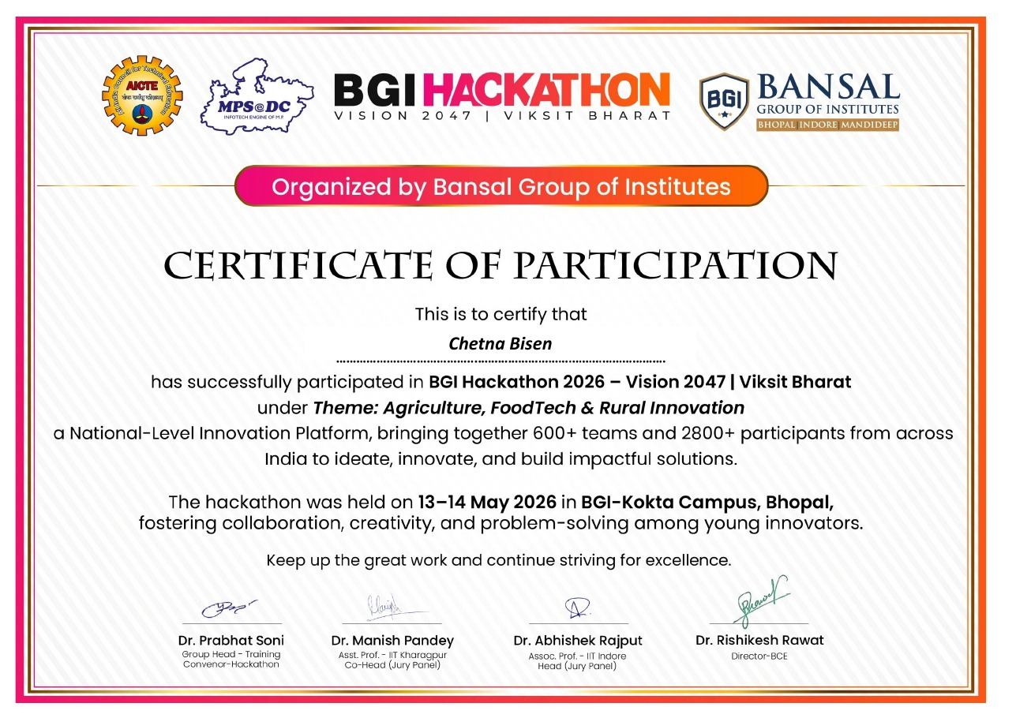
Figure 19: Certificate of Participation issued to Chetna Bisen for BGI Hackathon 2026
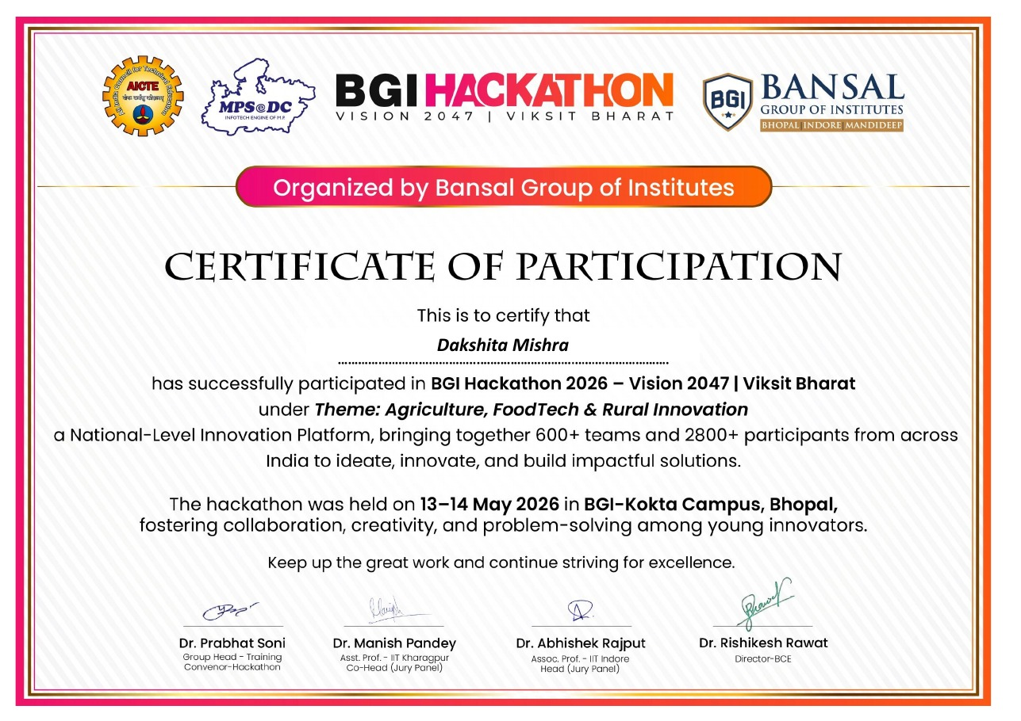
Figure 20: Certificate of Participation issued to Dakshita Mishra for BGI Hackathon 2026

11. Conclusion
Khet Se brings farmers and consumers onto a single transparent platform, combining fair pricing, AI-assisted guidance, voice and multilingual accessibility, and local farm-to-home delivery. By eliminating middlemen, it can improve farmer incomes, give consumers fresher produce at fair prices, create local employment, and contribute to the digitization of rural India.

